|  |  |
| --- | --- |
| Type of Distruption | Number of Firms |
| Normally Operating | 915 |
| Demand Critically Disrupted | 577 |
| Inventory Critically Disrupted | 513 |
| Distribution Critically Disrupted | 668 |

|  |  |  |  |  |
| --- | --- | --- | --- | --- |
| **Features for MC-SVM Model** | Inventory Turnover Ratio(***ITR***) | Customer Service Level (***CSL***) | Stadard Deviation Of Demand(***Stdd***) | Percentage Of Ontime Distribution(***POD***) |
| **Normal** |  |  |  |  |
| **Inventory**  **Disruption** |  |  |  |  |
| **Demand**  **Disruption** |  |  |  |  |
| **Distribution**  **Disruption** |  |  |  |  |

remains same Decreases massively decreases

**value of POD for 100 sample firms from all 4 type of category:**

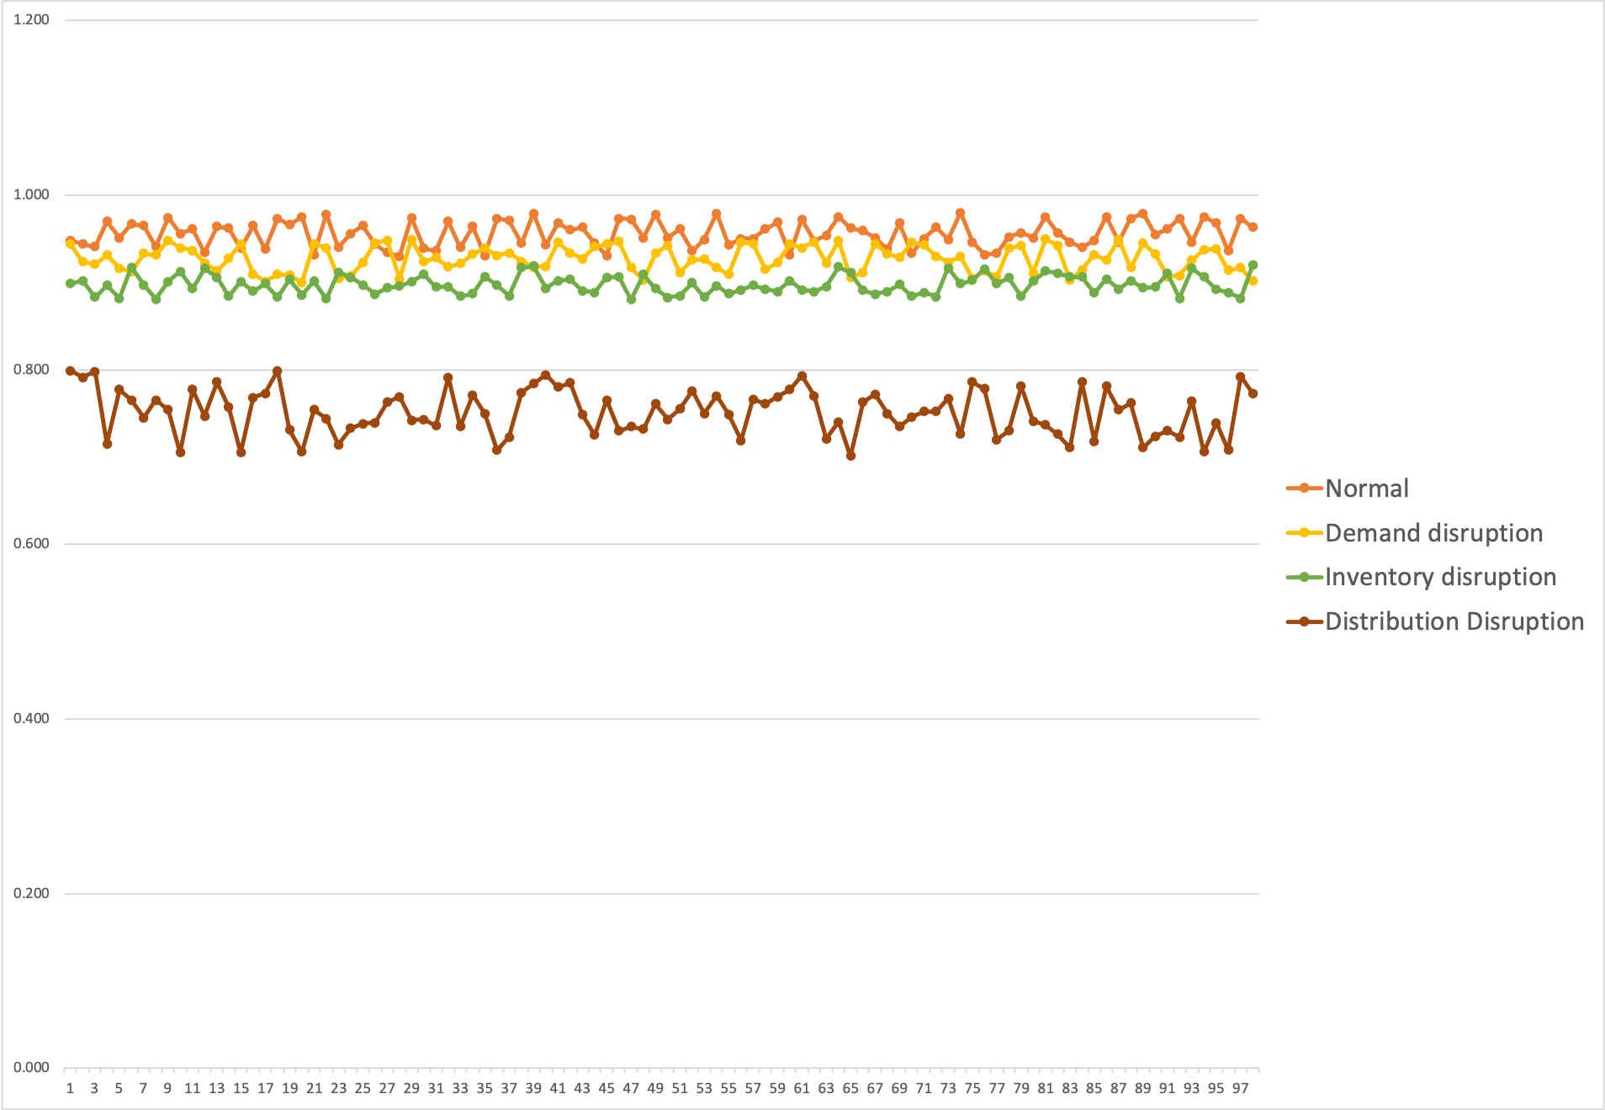

**value of *ITR* for 100 sample firms from all 4 type of category:**

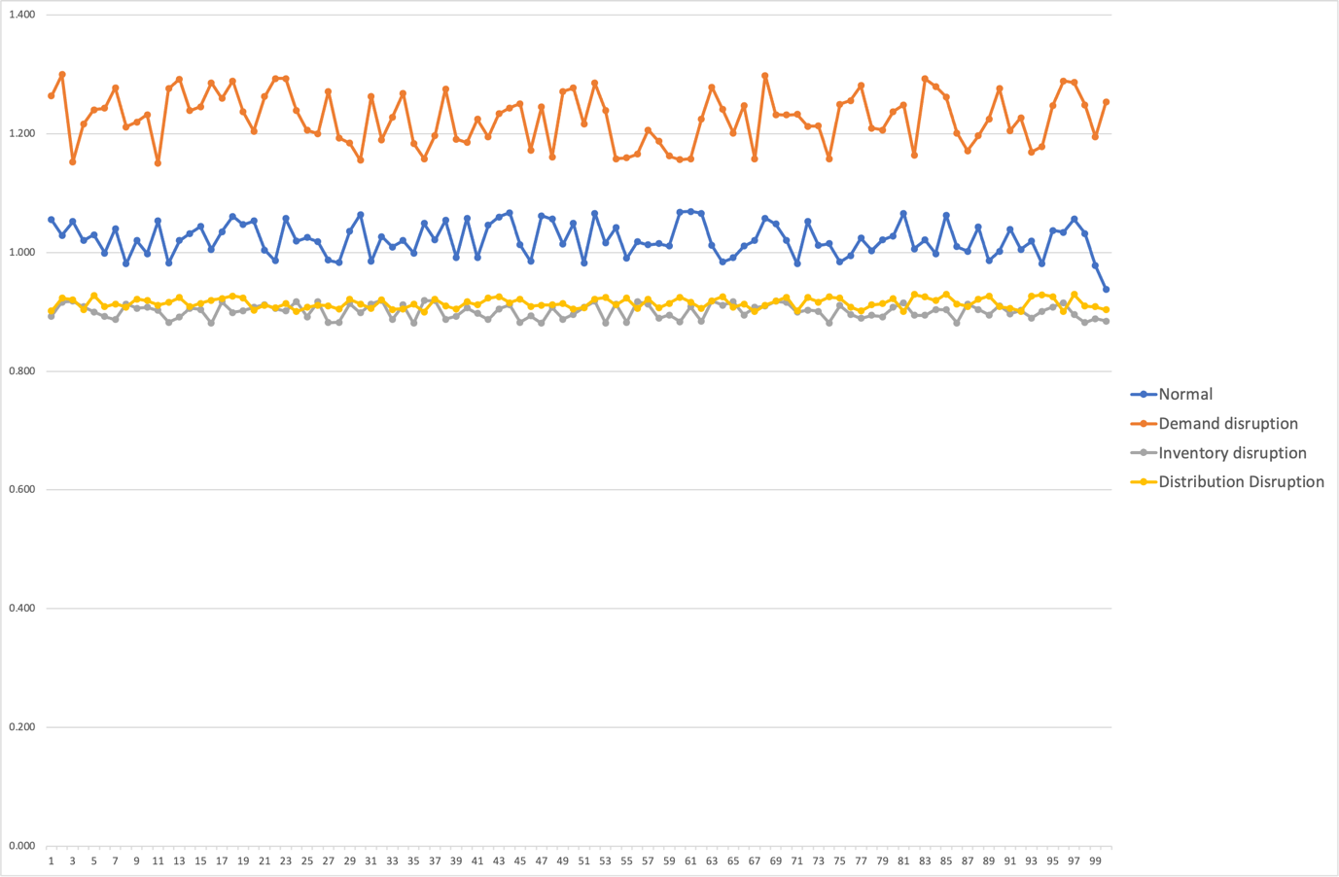

**value of *Std* for 100 sample firms from all 4 type of category:**

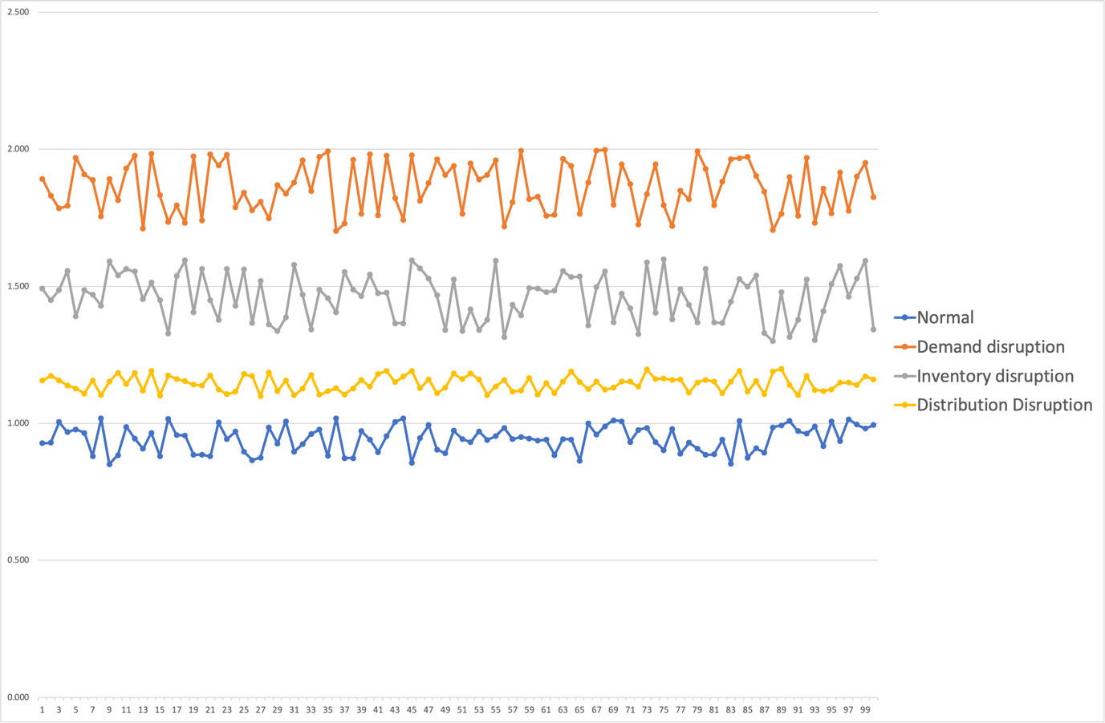

**value of *CSL* for 100 sample firms from all 4 type of category:**

